



Henry Simmons

| University of Plymouth |

| Norwegian Institute of Water Research |

Developing and Evaluating drone-based image analysis for coastal habitat classification

**Abstract**

Shallow water coastal zones provide a crucial ecosystem services, including vital habitats like eelgrass and kelp forests, nursery grounds, refugia, and feed for numerous species. Due to anthropogenic pressures such as coastal development and climate change, these shallow water habitats are at greater risk now more than ever. Mapping and monitoring these systems is integral to understanding their respective ecology, and to potentially inform management parties in marine protected area planning. Traditional mapping techniques involve in-situ data collection and are time and cost-ineffective. Novel remoting sensing technologies allow large areas of coast to be cost-effectively photographed with high resolution (3cm x 3cm) imagery in a comparatively short space of time. The first aims of this study were to investigate marine shallow water habitats in the costal zone. The second being to develop novel techniques and technology to improve shallow water habitat mapping using flying drones; through cost effective solutions for future research and management. This study demonstrates how multispectral images captured via small UAVs can be used to map habitat types within the shallow water coastal zone using a model created with a multinomial logistical model in R. Several habitat classes were distinguished, including brown, green and red algae, as well as rock, sand and lichen. Results from this study showed that pixel intensities from multispectral images can be used to create an effective model, however larger datasets and stricter sampling techniques than presented here are needed to better your model. The overall project shows the weaknesses and benefits of using a multinomial logistical model approach in multispectral image analysis.

**Keywords**

- Remote sensing – Habitat classification – Multispectral – Image analysis – Oslofjord -

**Introduction**

Shallow water coastal zones are able to support a high diversity of important underwater habitats for fish, birds, crustaceans, invertebrates, microbes and plants to flourish (Diaz &Schaffner, 1990). These coastal zones include some of the most productive marine habitats on the planet; such as shallow vegetated habitats, biogenic reefs, maricultures beds, soft and hard bottoms and open waters to name just a few (Reitz et al., 2014). The importance of these habitats has long been acknowledged as invaluable for fish and invertebrates; specifically, in the role they play in the early life stages of many species (Elliot & Hemingway, 2002). We know that many species rely on these shallow water habitats in order to fulfil parts of their life cycle; while Survival, growth and reproduction rates are all influenced by the quality of said habitat (Allain et al., 2003). Old et al. (2011) reported that overall habitat quality and connectivity are two of the most essential characteristics in healthy coastal systems (Lipcius et al., 2018).

These habitats are under constant pressure, now more than ever. Anthropogenic stressors such as coastal development and habitat degradation are at an all-time high; It is estimated that between 1960-1995 a kilometre of European coastline was developed every single day. While most European countries have losses of coastal wetlands and seagrass meadows of 50% in that same space of time at least, and some countries having recorded an 80% loss (Airoldi & Beck, 2007). Furthermore, Byrant et al (1995) recorded that 86% of European coast were at moderate or high risk of unsustainable coastal construction and development. The utilisation and development of coastal zones has greatly increased in the recent decades and these coastal zones are undergoing tremendous socio-economic and environmental changes – a trend that is showing no signs of slowing down in the future (Neumann et al., 2015). Recent global trends suggest that by 2025, 6 billion of the worlds human population will be living in the coastal zone and with that increasing population comes the associated habitat loss and its ecological consequences; such as a decline in biodiversity (Kennesh., 2002).

However, all hope is not lost. In Europe, for example, the established EU Natura2000 network of MPAs aims to protect the most threatened habitats and their associated species – although, without a clearer constant understanding of these habitats and their temporal and spatial changes, they remain still at risk (Sunblad et al., 2011). In an ecological utopia, to aid in our understanding of these threatened habitats and species, a constant monitoring system that would give us high quality, real time feedback on habitat types and conditions in the coastal zone. The data could be reviewed over time to monitor changes in habitat patch size, the movement of organisms such invasive species, marine litter, marine mammals, seabirds and the geological landscape could all be monitored.

While traditional monitoring efforts can be arduous, time-consuming and expensive when covering large spatial areas; with the use of novel remote sensing, this ecological utopia may not be too far-flung (Murfitt et al., 2017). Although satellite imagery has been readily available since the 1960’s with satellite systems from the Copernicus and Landsat programmes providing aerial imagery; these images are often to coarse to get a detailed understanding of the shallow water habitats in question. The images have often had a 30-300 metre meter pixel resolution, so smaller details were unobservable. However, the last five years has seen a prolific increase in the number of satellite platforms and the spatial resolutions of civilian-available remote sensing techniques (Rogan & Chen, 2003). With increased resolution we may be able to identify different habitat types, and possibly go as far as individual species. This knowledge of an environment should give us some insight into the habitat quality, and with enough knowledge of shallow water habitat ecology, a potential understanding of the assemblage present (Dokulil., 2003).

The applications of remote sensing technology in coastal research and monitoring has long been on the wish list of scientists and environmental managers, but accurate data acquisition has so far been hampered by technical challenges. However, during the last few years small flying drones, technically named unmanned aerial vehicle (UAV’s), have become available. Equipped with sophisticated optical sensors, UAVs support high resolution (cm-scale) data acquisition of coastal and shallow water habitats in near-real time. The technology is still in its infancy, but the potential applications are numerous.

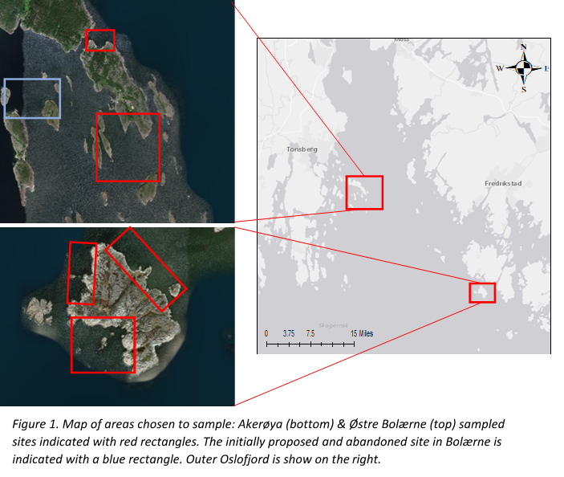This project has two main aims: the first being to map and investigate marine shallow water habitats in the coastal zone, with the second aim being to develop and test novel techniques and technology to improve shallow water habitat mapping using flying drones; here, through providing increased coverage and cost-efficient solutions for future research and management. Using both fixed wing (eBee X, SenseFly) and rotor blade (DJI M600) drones fitted with RGB and multi-spectral cameras, we want to produce high resolution images of the near-coastal zone (beach to ~5 m depth) in two marine national parks within the Oslofjord.

The drone recorded images will be used to create a habitat classification tool that will enable large coastal and shallow water areas to be habitat mapped with relative ease, and cost-efficiency. Images of certain quality and relevance will also be used by the National parks in dissemination of knowledge.

This work has huge potential to change the way we monitor our coastal as well as in-land regions (Noor et al., 2018). The money, time and effort that goes into surveying can be greatly reduced with the use of remote sensing from flying drones. Furthermore, we already have access to a huge database made-up-of decades of satellite imaging; while drone imaging efforts could be set up along the coast for future routine monitoring.

**Method**

**Sites**

This project spans across two national parks in southern Oslofjord. Færder national park to the west, and Ytre Hvaler national park to the East.

Ytre Hvaler national park is influenced by the large freshwater output of the Glomma river, meaning the system is more brackish. The conditions in Færder national park are much more marine; giving us the belief that we would achieve a more varied range of habitats to sample.

At each location, sites of interest believed to build a representative picture of the areas we chose to map: In Hvaler national park we planned to capture images of three sites of interest across Akerøya island (59.047278, 10.882570), however time and weather permitted us to sample the entire circumference of the island.

Within Færder National Park (59.198652, 10.573015) however, due to bad weather only one of the two originally chosen study areas was sampled. Instead, after one area was successfully sampled, we moved to a more sheltered bay on the north side of Østre Bolæren where we could fly the drones at a lower altitude to avoid strong winds (10m+/s).

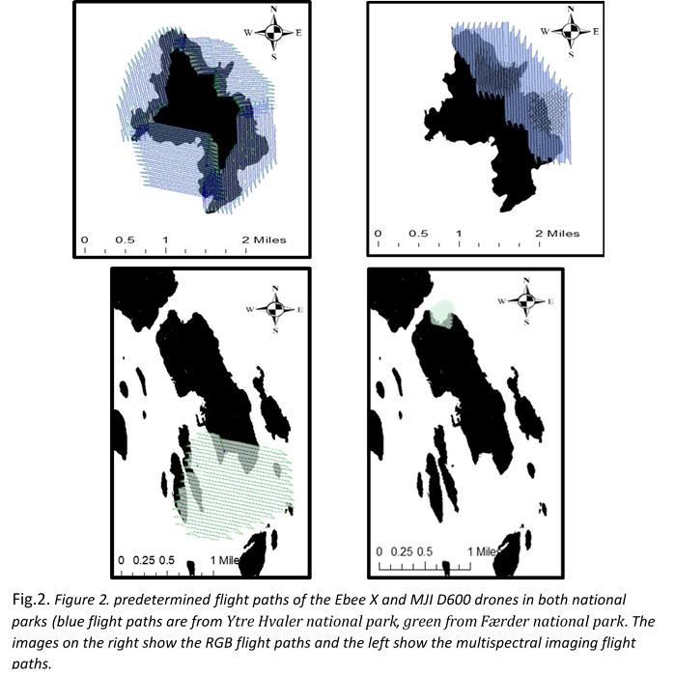

**Airborne remote sensing**

Two types of drones were used to collect our remote sensing imagery between 23rd-27th August 2019: The Ebee x fixed wing drone and the DJI M600 rotor blade drone. Both drones were equipped with RGB and/or multispectral (MS) cameras customised to capture data of different wavelengths of electromagnetic light. The separated bands have known strengths in remote sensory imaging:

* Blue: Deep wate and atmospheric imaging - 450-520nm.
* Green: Vegetation and deep-water structures - 520-600nm.
* Red: Man-made objects, soil and vegetation - 600-690nm.
* Red-edge: Vegetation - 690-750nm
* Near-infrared: Vegetation - 750-900nm

10 pre-programmed flight paths were flown across the five days, with an approximate total flight time of 8h (See Fig.2.). The drones were flown between altitudes of 80-120m, taking a total of 42,337 images with a 70-80% overlap, to increase the quality at pixel level. In the initial post-processing procedure and image calibration, 27,213 of the single images were stitched together to create single mosaic pictures.

Only 64.35% of the total images were used in the stitching process due to image quality controls set it place to avoid the use of distorted images such as those with high levels of surface-water reflection.

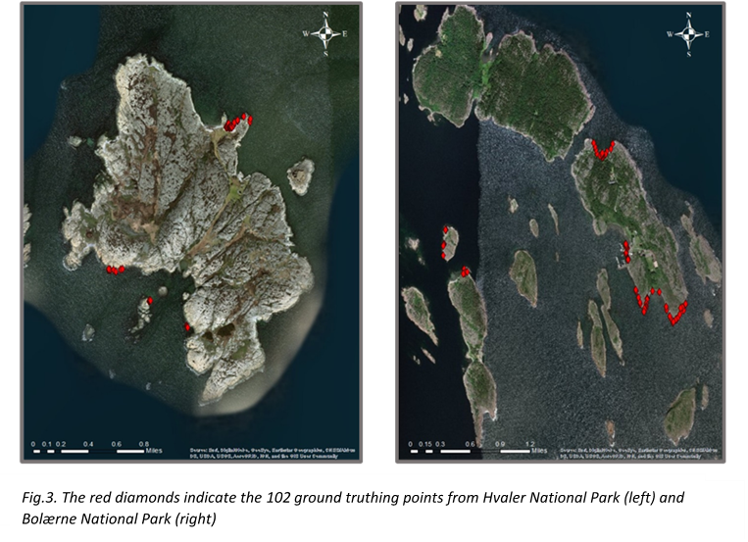**Ground Control Points** (GCP) were positioned with an even distribution across the area of interest in order to improve the accuracy of the geolocalization from the meter scale to a cm scale. A real time kinematic GPS receiver was used to accurately measure the GPS coordinates of specific landmarks; in this case, 50cm x 50cm white crosses were placed in easy to spot locations. These crosses were left out during the drone flights, in areas where they were unlikely to be disturbed.

With precise georeferencing of these crosses, we would then correctly stitch the images in the post-processing stages with accurate geolocalization. We used the following coordination systems:

* Image coordinate system: WGS 84
* Ground control point coordinate system: WGS 84 (2D)
* Data analysis Coordinate system: WGS 84

The multispectral Mosaic images and data were then converted into 5 tiff. files, which are raster files compatible with GIS software, google earth and R for visualisation and analysis.

**Ground truthing points (GTP)**

A total of 102 GTPs were sampled. This involved using the same real time kinematic GPS receiver used for the GCPs. The GPS receiver was placed on an area of least 1m2 of a known homogeneous habitat. From the 102 GTPs, the habitats were split into 10 habitat type descriptions (see table.1.)

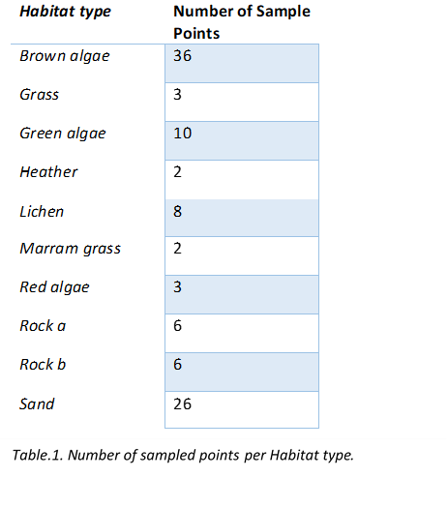

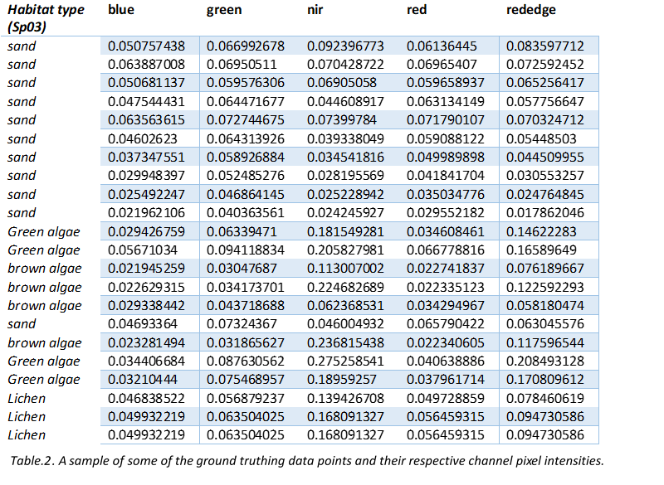

These data points were then converted into a tiff file compatible with the MS raster sheet data. The GTP were then layered on top the MS raster files, georeferenced using the same technique as the GCP, and now we had areas of known habitat type overlaying Multispectral data which can be further analysed.

Version 3.5.2. of R studio was used for data manipulation. Importing the five different channels’ tiff. files into R as raster layers, and using the plugins ‘raster’, ‘rgdal’ and ‘tidyverse’ we used the ‘stack’ function to stack the five raster files on top of each other, ensuring they the georeferenced GCPs lined up correctly. We then used the ‘dplyr’ package to add our GTPs data as an additional layer, on top of the multispectral raster files; once again ensuring they were georeferenced and using the same coordinates system (WGS 84). We then used the ‘extract’ function to extract the pixel values of the 102 GTPs across all five spectral bands.

This gave us a single pixel of known habitat, with values for all five channels; with a large sample size of GTPs, we had a collection of associated pixel values for all five channels for each habitat type; this is the data set we then built our model with (see Table.2.).

**Data Handling**

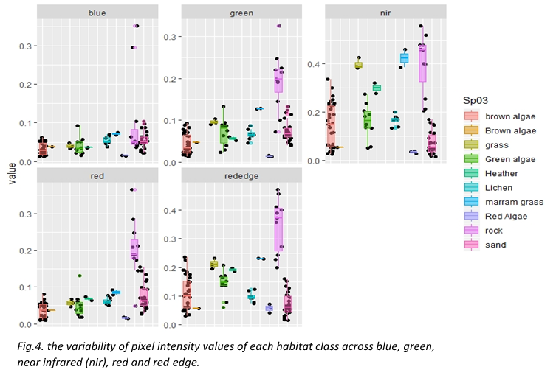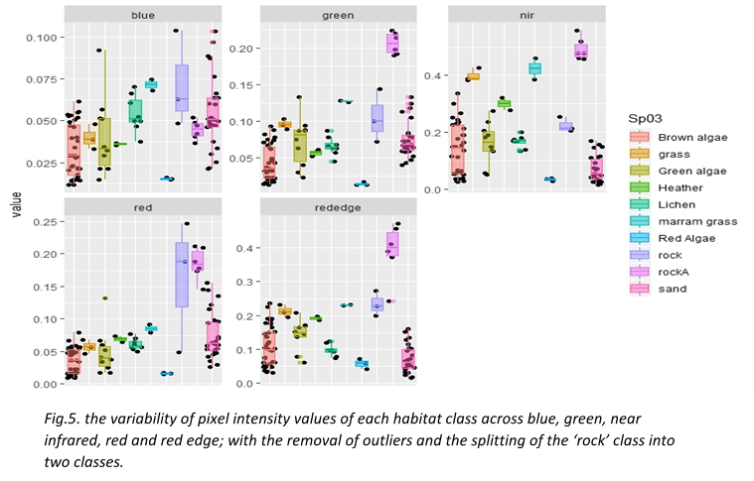

To visualize our data, we created a bar plot; showing where any similarities or difference in pixel intensity lie between the habitat type groups (see fig.4.). From this barplot we could identify the spread of data within individual groups and note any outliers. From this visualization we decided to collapse the ‘brown algae’ class, identified outliers in the blue and green channels and removed them, and noticed that the spread of data within the ‘rock’ habitat class appeared non-uniform in spread and indicated two possible groups within the spread. Possibly due to the wetness of the rock surface. Therefore, we then split the rock group into two individual groups to aid our model (see Fig.5.).

**Mlogit model**

Once our data had been split into the appropriate classes, we conducted an multinomial logistic regression (mlogit) analysis to build a model that could be used in our habitat classification tool. The multinomial logistic regression model is a discreate choice model, meaning that given a set of conditions (i.e. channel signals) it can be used to predict which outcome (i.e. habitat type) of a set of possible outcomes that is the most likely. We trained our model by feeding it the ground truthing data – giving it an understanding of how the different pixel intensities from the various channels could help determine the habitat class type (see Table.1).

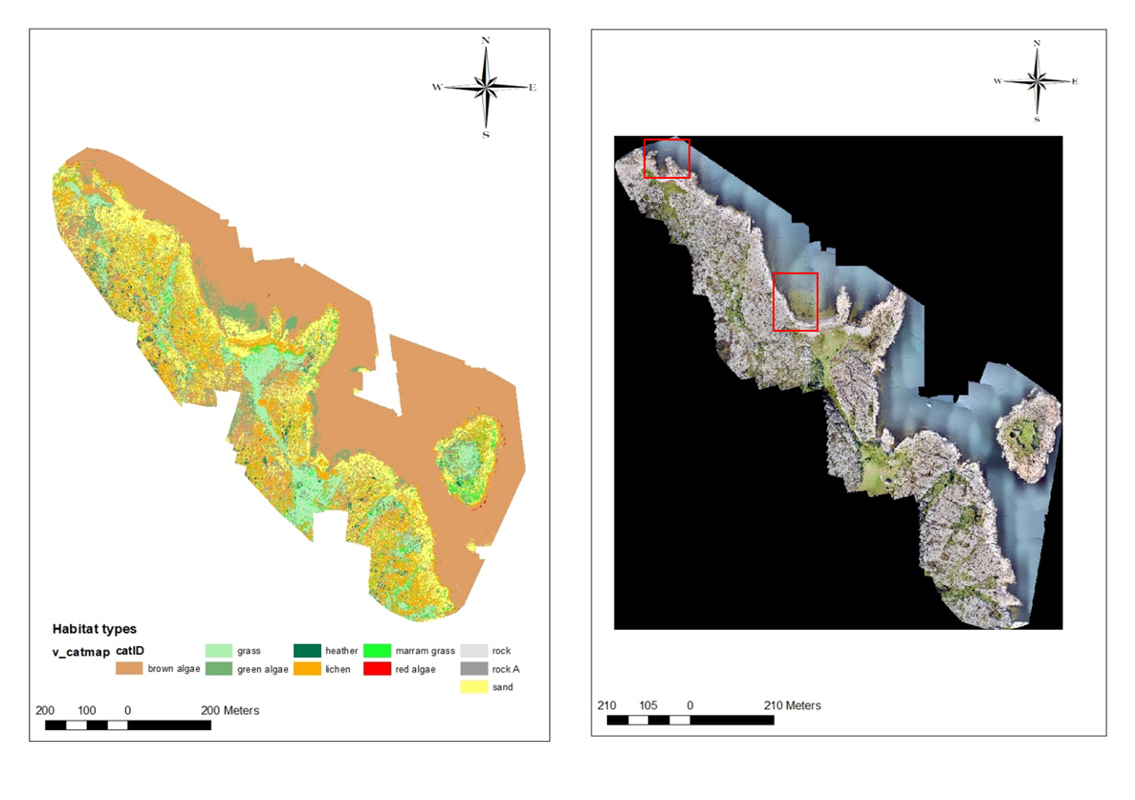

*Fig.6. Composite map of the predictive model’s output (left) in comparison to a true colour image of the same area (right), with red rectangles representing the areas shown in figure 7.*

An initial fear was that given the small amount of data, the model could easily be over-fitted. This fear may be further augmented by the splitting up of categories and the removal of outliers. However, when differences in groups are clear, such as wet and dry rock within the rock class, a more detailed model could be made. We measured the predictive power and fit of our Mlogit candidate models using the Akaike’s Information Criterion (AIC), the log-likelihood ratio test and the McFadden R2. In order for us to affirm our model to have a “good” fit the McFadden value should fall between 0.2 and 0.4, and the best model is considered the candidate with the lowest AIC-value.

We did model selection in a forward manner, subsequently adding the term that lowered the AIC-value the most. The model deemed best included four of the five channels; namely nir, green, rededge and blue.

**Mlogit Results**

mlogit(formula = Habitat_type ~ 1 | +nir + green + rededge + blue, data = d5,

    method = "nr")

**McFadden R^2:**  0.92803

Likelihood ratio test : chisq = 330.62 (p.value = < 2.22e-16)

**AIC:** 115.6396

Based on the McFadden score we can say that our model has a good fit We compared the observed data to predictions made from the ground truth data set, in order to get a feel for how the model performed across classes (see fig X1). However, this test of validity is not fully reliable, seen as we used the same data set for both the modelling and the testing.

Figures 6 and 7 provide further visual aid for the manifestation of our mlogit model, in comparison to the true colour RGB images.

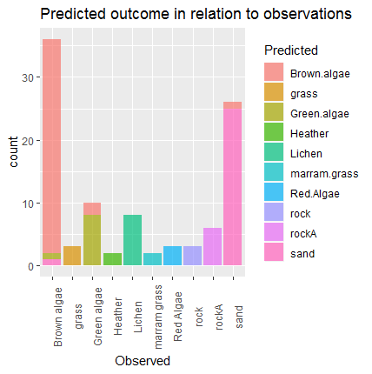

**Predictions**

In the case of spatial predictions, the ‘predict’ function does not work out of the box for mlogit-models. We therefore first had to convert the raster-stack into a matrix, with each column representing a single raster layer (i.e. channel). We then created a dummy response (which is needed in order to create a mlogit-data frame), and did the predictions on that frame using the standard ‘predict’ function.  
However, because this was done on a huge data frame, the data was spilt into chunks using the ‘blockSize’ function. The predictions were then written directly to a raster brick file in chunks. Each layer of the brick file represents one habitat type, and the layer gives the probability of finding that habitat type within each pixel in the image-stack. We then extracted information on which layer had the highest predicted probability in each cell, and from this produced a composite map showing the most likely overall distribution of the different habitat types.

Model predictions generated from the multispectral images captured by our drones are visualized in Fig.6&7.

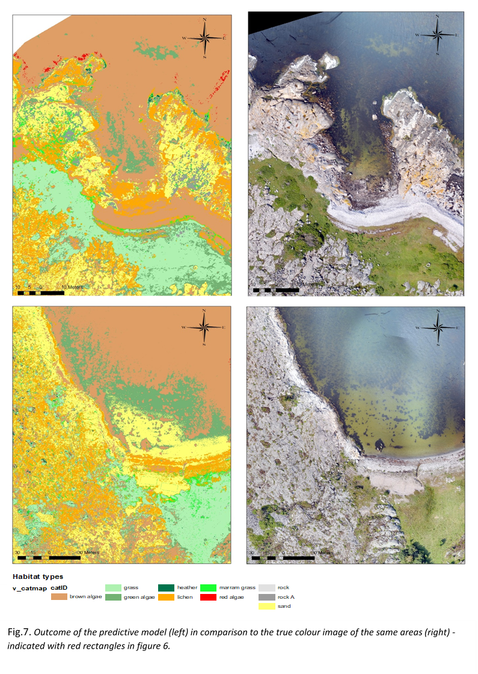

*Fig.6. Composite map of the predictive model’s output (left) in comparison to a true colour image of the same area (right), the areas shown are indicated in figure 6 with red rectangles. .*

**Discussion**

Our predictive model shows great potential in the field of remote sensing technology in coastal research and monitoring. However, there are clear alterations we could make to better our model.

Starting with the sampling technique; The first obvious improvement could be the sample size. With a greater dataset we should get a more representative spread of data for each habitat type. We could do this with relative ease by extracting data from the pixel intensities of the 1m2 area of known homogeneous habitat type surrounding each GTP – this would increase our sample size drastically and can be done in the near future.

Table two shows an uneven distribution in sample data across habitat types; ideally, - if the area sampled allows it, a standardised sampling procedure would be in place whereby we obtain an even spread of sampling points across all habitat types of interest. This sampling method could also note the different sub-groups within habitat classes. For example, the spread of data shown in rock class in figure 4 could be down to the ‘wetness’ of the surface of the rock. Taking these subtle differences can have a huge effect on our model. – as well as indicating tidal and splash zones for later analysis.

Furthermore, our composite maps show a clear issue interpretation of data from green algae and terrestrial vegetation. Occasionally sampling the latter as green algae. This can easily be amended with adding in other variables such as altitude – similarly, this would help distinguish between living algae and dry algal litter on the shore.

Moreover, the model interpolates deep water as brown algae. With the inclusion of some data points from deep water, we should be able to distinguish where we our depth limits are, and we can no longer classify shallow water habitats due to the obstruction from the water column.

In addition to this, with a greater data set we would have the confidence to train our model using only 2/3 of the data. While using the remaining third to test the model’s accuracy against a new, correctly mapped data set.

Currently, the validation of our model is not accurate, because we test the model on the same data set that we trained it with. In order to further test the predictive power of this particular model, we could have experienced researchers identify habitat types from RGB images of new areas, and later apply the model to the same new images, noting the difference in the observed and modelled habitat types.

Another obvious direction this research could head in is the to alter the specificity of the habitat groups. Taking a less precise approach and having habitat classes such as “terrestrial vegetation”, “marine vegetation”, “rock” etc. would speed up the process and give a broad overview of the areas being sampled. On the other hand, applying the same principle, one could approach the model on the species level; this would be better approached with hyperspectral imagery.

The work outlined here only scratches the surface of the multitude of potential applications of novel remote sensing technologies. The Norwegian Research Council has recently funded a new infrastructure project run by NIVA, named SeaBee, which looks to delve deeper into the potentials of these technologies. The next steps include the involvement of hyperspectral images, which will enable us to more accurately determine different habitat types. NIVA also wish to set up routine automated image analysis for large scale coastal monitoring systems, with the aim of quantifying marine debris, mammals and seabirds.

**Acknowledgments**

The author would also like to thank Mats Walday, Siri Moy and Eli Rinde for their assistance in collecting ground truthing data and providing great company on this project’s fieldwork. Thank you to Spectrofly ApS’ Robert Paulson and Anders Vindelev for their drone flying work and their crucial work in the post-processing imagery work. A special thanks to Guri Sogn Andersen, for her incredible and continuous work within R; building the model and saving me from all-manner of errors. The author would also like to thank Romy Lansbergen from the Technical University of Denmark for her hard work laying the path for me on previous projects with NIVA. Lastly, the author would like to thank Kasper Hancke for his direct supervision throughout my stay at NIVA Oslo, making the time to answer my questions and debate methodology. As well as include me in a wide array of mentally stimulating activities; from seminars to shuffleboard.

**References**

Airoldi L., Beck M. W., Loss, status and trends for coastal marine habitats of Europe, *Oceanography and Marine Biology:* an Annual Review, 2007, vol. 45*, pp. 345-405*

Allain G., Petitgas P., Grellier P., Lazure P., The selection process from larval to juvenile stages of anchovy (Engraulis encrasicolus) in the Bay of Biscay investigated by Lagrangian simulations and comparative otolith growth*, Fisheries Oceanography*, 2003, vol. 12, *pp. 407-418.*

Bryant D., Rodenburg E., Cox T., Nielsen D., ‘Coastlines at Risk: an Index of Potential Development-Related Threats to Coastal Ecosystems,*’ WRI Indicator Brie*f, 1995, DCWorld Resources Institute

Dokulil, M.T., *Algae as ecological bio-indicators,* Trace metals and other ecological bio-indicators, 2003, vol. 6, *pp. 285-327.* <https://doi.org/10.1016/S0927-5215(03)80139-X>

Elliot, M., Hemingway,. K. L., Fishes in Estuaries, Journal of Fish biology, vol. 64, *pp. 1462-1466,* <https://doi:10.1111/j.10958649.2004.00419.x> , available online at http://www.blackwell-synergy.com

John Rogan., Dongmei Chen., Remote sensing technology for mapping and monitoring land-cover and land-use change, *progress in planning,* 2004, vol. 61*, pp. 301-325.*

Kennesh M. J., Environmental threats and environmental future of estuaries*, Environmental Conservation*, 2002, vol. 29, *pp. 78-107*

Murfitt, Sarah L., Blake M. Allan, Alecia Bellgrove, Alex Rattray, Mary A. Young, Daniel Ierodiaconou. Applications of unmanned ariel vehicles in intertidal reef monitoring. Scientific reports 7 (1): 1-11. <https://doi.org/10.1038/s41598-017-10818-9>.

Mohd N Noor., Abdullah A., Hashim M., (2018b) Remote sensing UAV/drones and its applications for urban areas: a review. *IOP Conf Ser Earth Environ Sci* 169, <https://doi.org/10.1088/1755-1315/169/1/012003>.

Neumann B, Vafeidis AT, Zimmermann J, Nicholls RJ (2015) Future Coastal Population Growth and Exposure to Sea-Level Rise and Coastal Flooding - A Global Assessment. PLoS ONE 10(3): e0118571. https://doi.org/10.1371/journal.pone.0118571

Olds, A. D., Connolly, R. M., Pitt, K. A. & Maxwell, P. S. Habitat connectivity improves reserve performance. *Conserv. Lett.* 5, 56–63 (2012).

Robert J. Diaz., Linda C. Schaffner., the Functional Role of Estuarine Benthos, *Advances in Estuarine Sciences,* United States Environmental Protection Agency*,* Virginia Institute of Marine Science, April 1990, *pp 25-27*

Rochelle D. Seitz., Håkan Wennhage., Ulf Bergström., Romuald N. Lipcius., Tom Ysebaert., Ecological value of coastal habitats for commercially and ecologically important species, *ICES Journal of Marine Science*, 2014, vol. 71, Issue 3, *pp. 648 665,* <https://doi.org/10.1093/icesjms/fst152>

Sundblad G., Bergström U., Sandström A.. Ecological coherence of marine protected area networks: a spatial assessment using species distribution models, *Journal of Applied Ecology*, 2011, vol. 48 *pp. 112-120*

Yves Croissant (2019). mlogit: Multinomial Logit Models. R package version 1.0-1.

https://CRAN.R-project.org/package=mlogit